Tast1. Trigger pipeline from repository
- Build and test the application
- Create docker image
- Deploy application to EC2
Step 1. Created EC2 instance
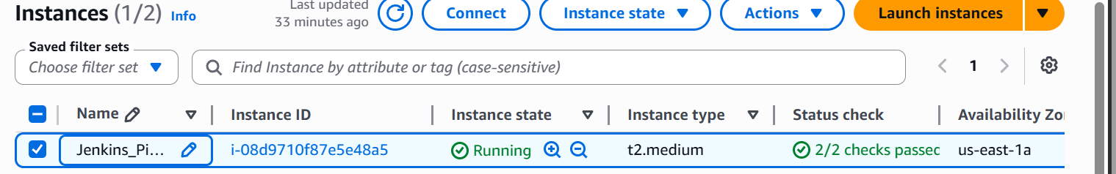
- Enable the inbound rule to access the application to public
- 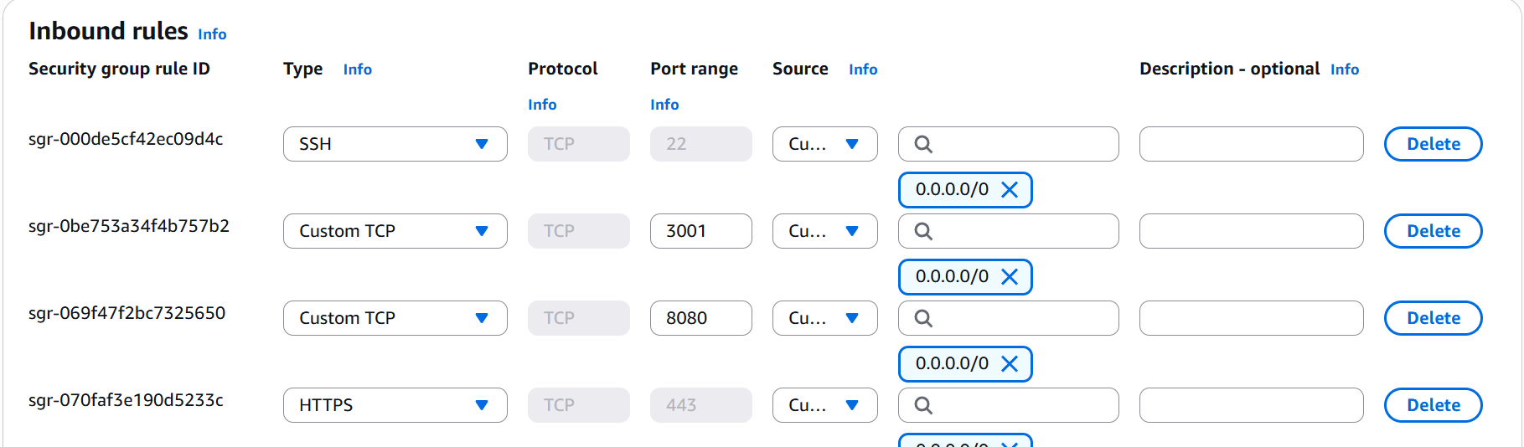
- SSH to the instance
- 1. Update the instance
- 2. Installed the Jenkins packages
- 3. Installed the docker packges
- Cloned the code
- 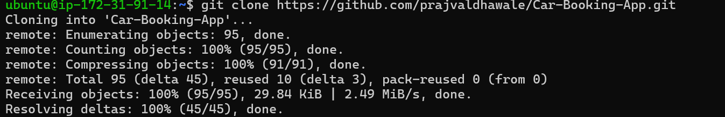
- Added required project files
- 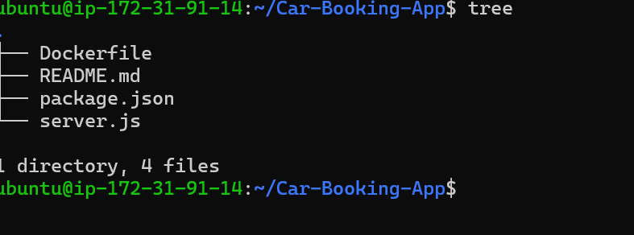

- Created Docker file
- 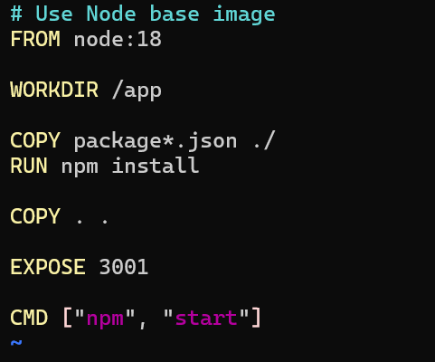
- Build and test the docker image locally
- 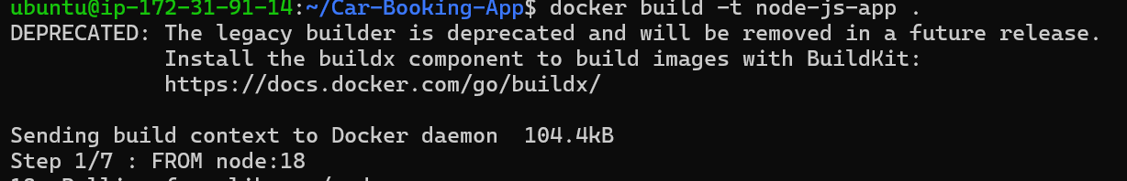
- 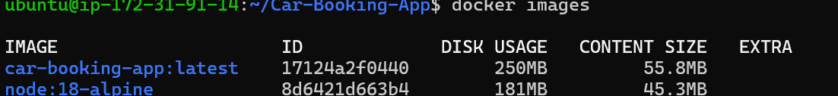
- Successfully build the image and run the container
- 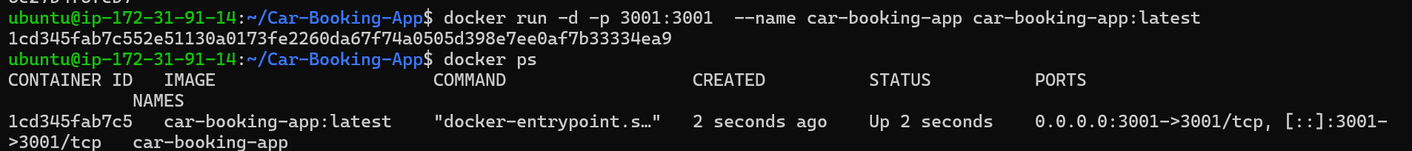
- 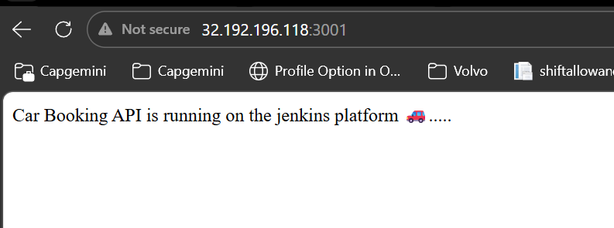

2. Now am deploying the same code into Jenkins pipeline using auto-trigger base
- select the declarative pipeline
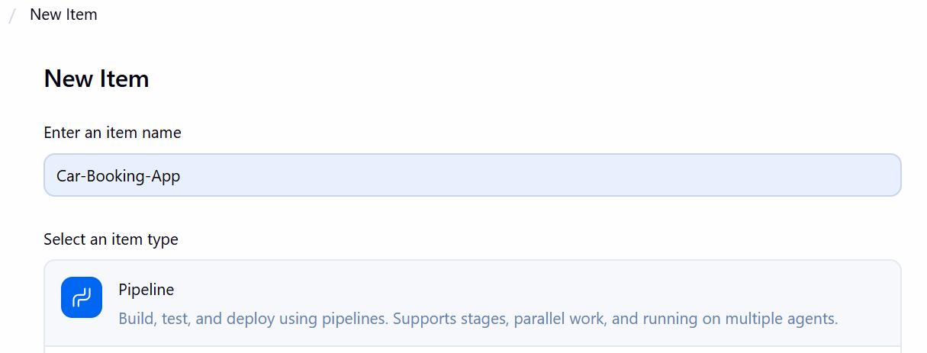
Configured the Jenkins on ubuntu server
- pipeline {
- agent any

- environment {
- IMAGE_NAME = "node-app"
- TAG = "${BUILD_NUMBER}"
- }

- tools {
- nodejs 'NodeJS'
- }

- stages {
- stage("Clone Code") {
- steps {
- git url: "https://github.com/prajvaldhawale/Car-Booking-App.git", branch: "main"
- }
- }

- stage("Build Application") {
- steps {
- sh 'npm install'
- }
- }

- stage("Test") {
- steps {
- sh 'npm test || echo "No tests found, skipping..."'
- }
- }

- stage("Build Docker Image") {
- steps {
- sh 'docker build -t $IMAGE_NAME:$TAG .'
- }
- }

- stage("Deploy Container") {
- steps {
- sh '''
- docker stop jenk-node-app || true
- docker rm jenk-node-app || true
- docker run -d -p 3000:3000 --name jenk-node-app $IMAGE_NAME:$TAG
- '''
- }
- }
- }
- }

- Installed the webhook plugin of git for automatically trigger the pipeline
Configure Jenkins Job
Chek GitHub hook trigger for GITScm polling

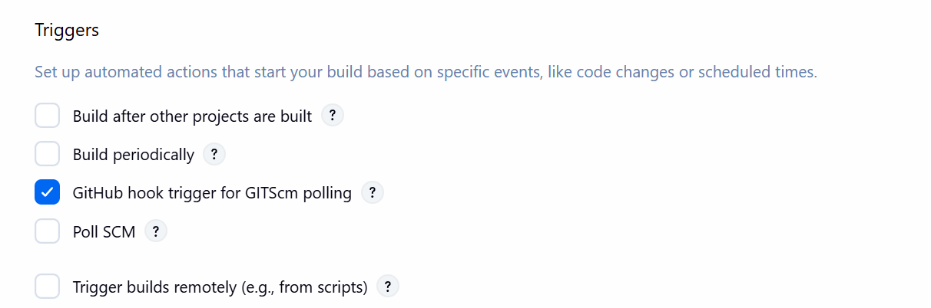

- Adding Webhook in GitHub
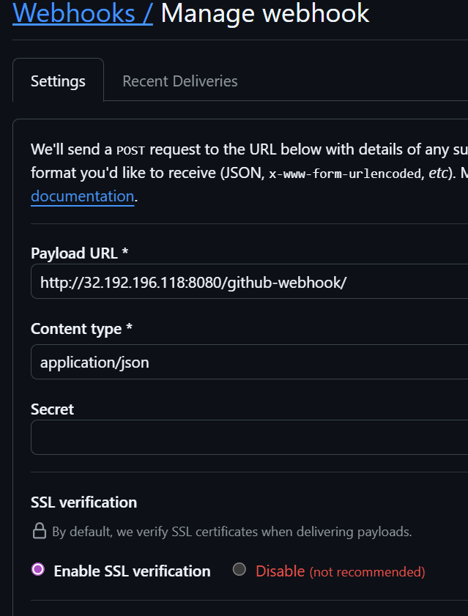
- Once I made in changes in the repository it will automatically trigger the pipeline
- 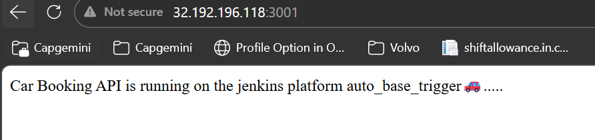

- Taks 2 Creating Terraform infrastructure Development QA and Production Environment
- Step 1
- Install terraform from official terraform website
- 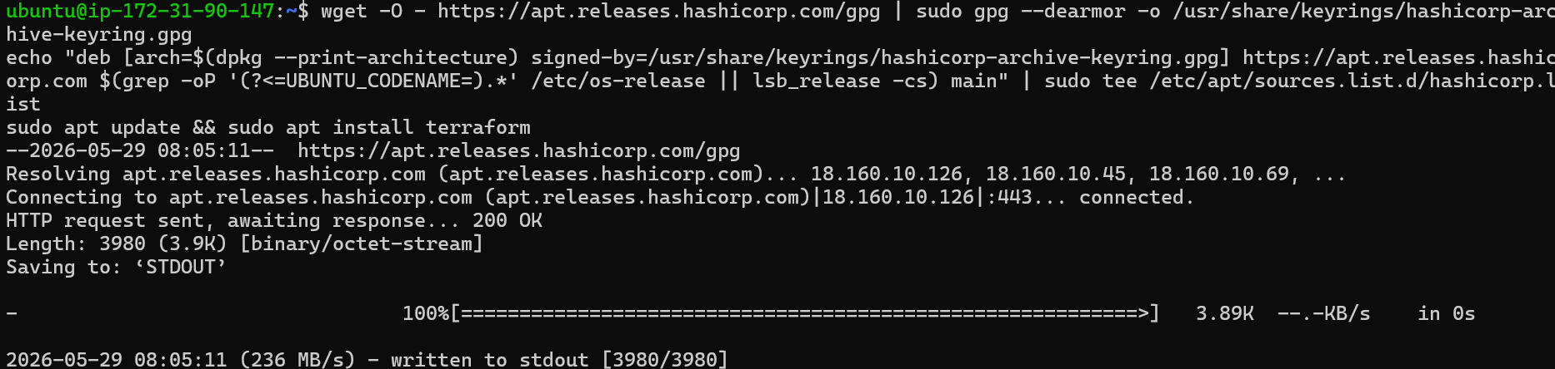
- Step 2
- Created terraform directory and terraform provider.tf
- 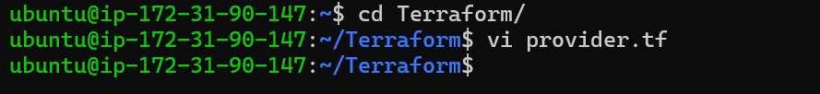
- Configure the provider
- 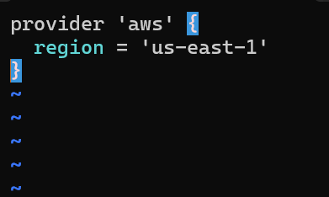
- Step 3
- Create main.tf file

- Step4
- Install AWS CLI and configure to connect with AWS services using terraform
- 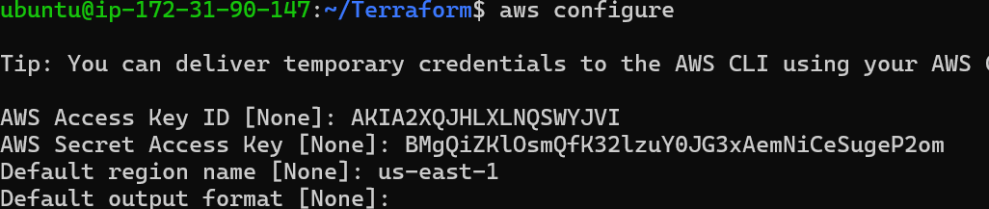

- Step5
- Initialise the terraform provider
- 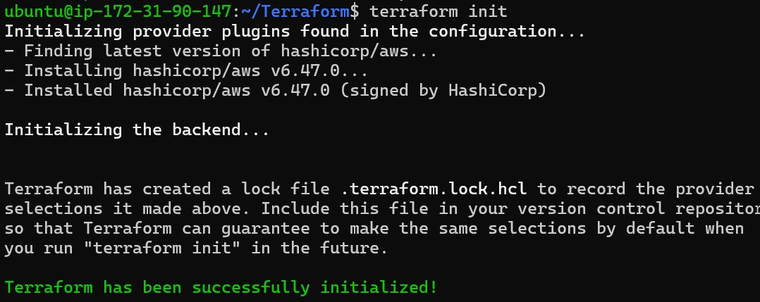
- Step6
- Configured AWS EC2 infrastructure and networking
- 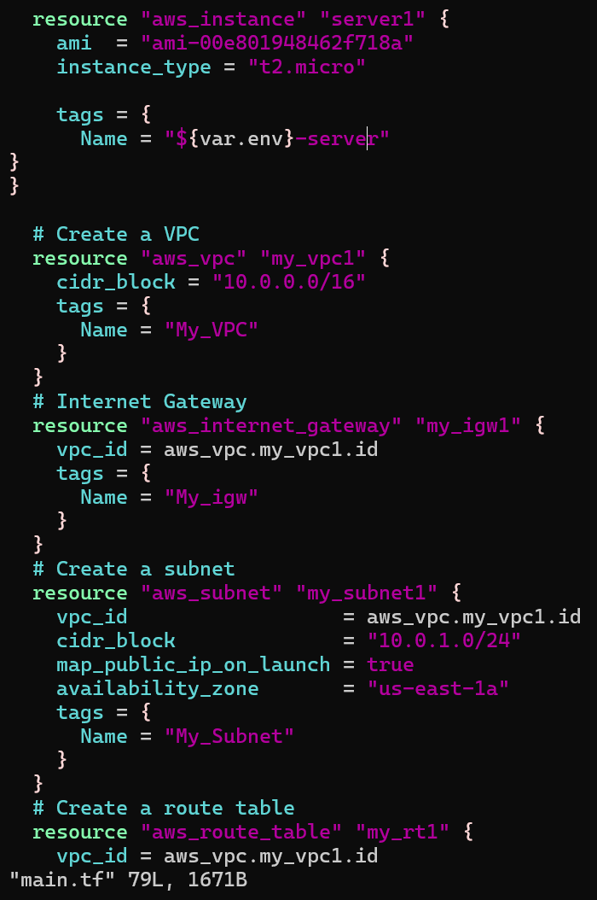

- Terraform plan & tera form apply
- 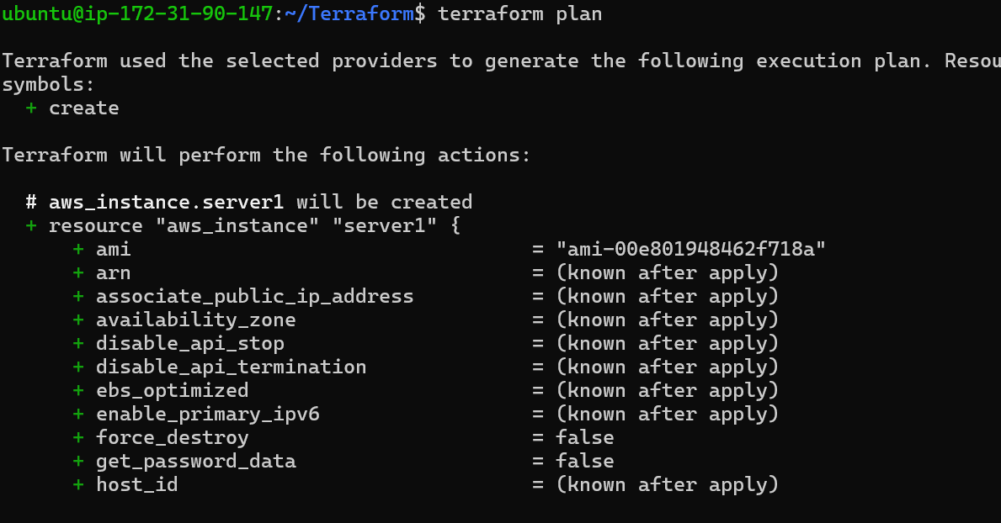
- 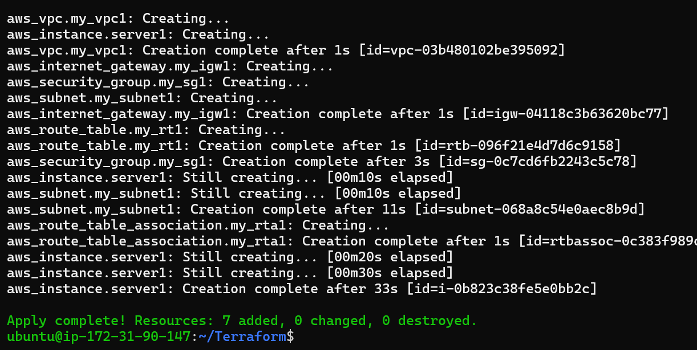
- Step7. Created multiple terraform infrastructure development, QA and Production Environment.
- Created environment structure
- 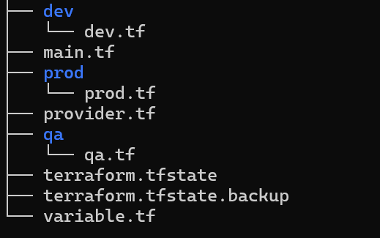
- 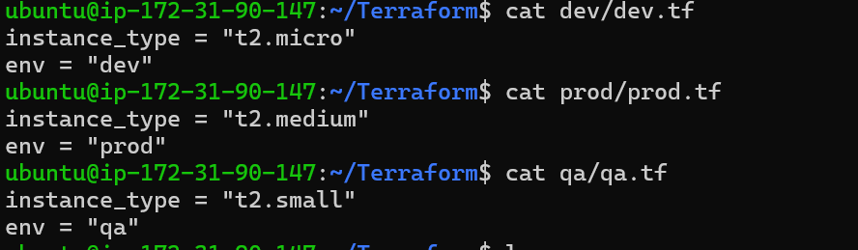
- Step8 – created variable.tf
- 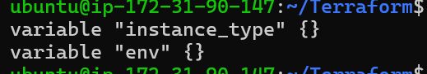
- Step9 update the env in the main.tf
- 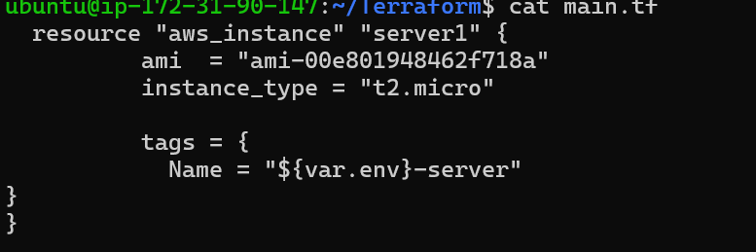

- Step10. Run the Dev Env
- 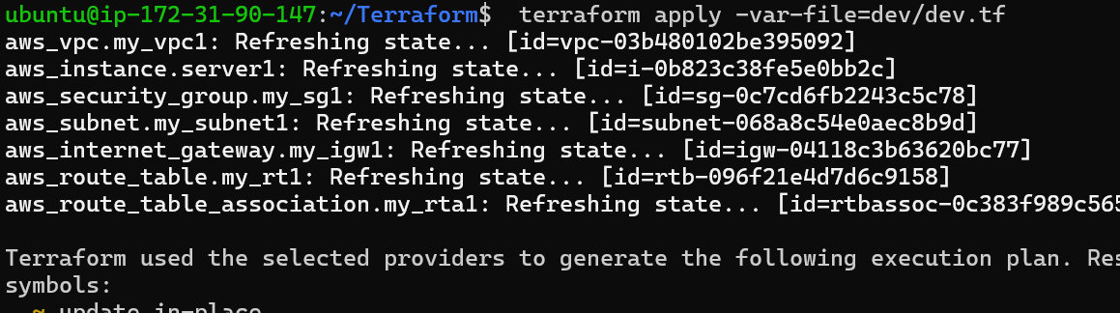
- step11. Run the QA env
- 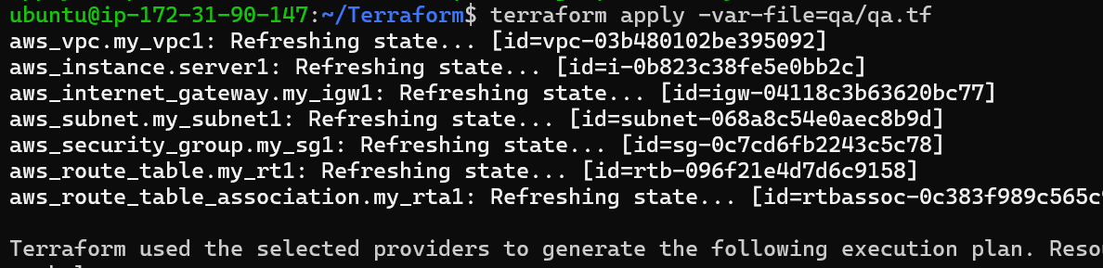
- Step 12. Run the Prod env
- 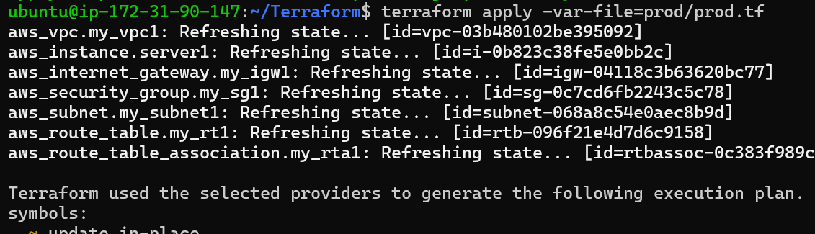

- Task3. Create Terraform pipeline for Terraform infrastructure and configure cloud watch.
- 